

TCP and OSPF Assignment

ELC 3080
Name | ID
عبدالرحمن أحمد عبدالحميد العدوي | 9202825
على أيمن محمد فولى | 9202891

Submitted To: Prof. Dr. Khaled Fouad

3rd Year – Spring 2023

Contents
1. TCP Lab 3
1.1. Effect of TCP Window Size 3
1.1.1. Vary iperf3 window size from 1Kbytes to 6 Kbytes in increments of 1 Kbyte, then set it to 12, 16, 24, 32 Kbytes. Plot the average throughput and the average number of retransmissions as function of window size. Comment on the results and explain the zigzag behaviour noticed for larger window sizes. Note that number of retransmissions is the 5th column in iperf3 default output & throughput is the 4th. You can plot data using matlab/python/any online graphing tool (Ex. https://chart-studio.plotly.com/create/#/). The window size is the last option in the iperf command (return to INTRO Lab). 3
1.1.2. Click on any of the TCP a data segment whose source is node n7, dissect the segment by following different protocol layer headers from TCP->IP->Ethernet identifying how many header bytes are added by each layer, identify the TCP options used. 6
1.1.3. Repeat for an ACK packet sent from node n11. 7
1.2. TCP short VS long paths 7
1.2.1. Compare the result of throughput with the case when connection was made to node n11. Why throughput drops when connecting to n8 although capacities on the two paths are the same. 8
1.3. Higher link Capacity with Drops VS Reliable Lower Capacity 8
1.3.1. Compare throughputs in cases a, b, c. Why b is better than c? 10
1.3.2. Compare throughputs in cases b, c and d. Which is better? Why? 10
1.3.3. Compare throughputs in cases e and f? Which is better? Why? 10
2. OSPF Lab 10
2.1. OSPF Link Cost Change 11
2.1.1. Check what happens to the path between n7 and n11 (as seen after steps 3 and 6)? Explain what happens. To help visualize the path choose toolbar->widgets-> Throughput. 11
2.1.2. Set the cost of eth1 at node n5 back to 10. Establish two iperf3 connections: one from n7 to n11 and the second from n11 to n7 both for duration of 500 seconds. Now go to node n4 and set interface cost for interface connecting n4 with n5 to 40. What happens in the paths of the two connections? Explain what happens. What do you conclude? 12
2.2. OSPF Database Updates 12
2.2.1. Capture and explain the outputs due to execution of step 2. Why some destinations have more than route in the routing tables? 13
2.2.2. After executing step 3, determine how long it took the network to exchange link state packets and adjust routing tables. (Hint: you can calculate the required time by observing the time of first OSPF update message and the last ACK from Wireshark). 14
2.2.3. After execution of step 4, identify the new routing table and router database at router n2. Explain the updates in the new routing table and the new database. 14
2.3. OSPF Link State Advertisement Periodicity 15
2.3.1. Bring router n4 down and then up again and determine how long it took the network to recognize the router is down/up. 15
2.3.2. Now, the following is a bonus question (extra marks). Explain the noticed behavior of the link state update packet storms (flooding) where it generally takes longer times for the LSP exchange to die out (i.e. LSP exchange stops) when a router is down as compared with the case when the router is up again. 16

TCP Lab
Each of the following sections describes an experiment based on the network topology provided by the Project_OSPF_TCP.imn file. In your report, divide the answers to correspond to one of these sections in exactly the same sequence and same name, for example use Question 2.1, Question 3.2 and so on. The Introductory Lab explained and introduced most of the needed tools like iperf3, vtysh, wireshark, etc. If you have not gone through it, do not start working on the assignment below. It is better to start the network emulation once and run Wireshark captures. You can reset Wireshark captures from experiment to another.

Effect of TCP Window Size
- Set wireshark filter to display TCP packets only.
- Start an iperf3 server on node n11.
- Start an iperf3 client on node n7 connecting to server on node n11 for a duration of 40 seconds and reporting interval of 10. Note that in iperf, the client is the node sending the traffic and the server simply receives and sends an ACK.

Vary iperf3 window size from 1Kbytes to 6 Kbytes in increments of 1 Kbyte, then set it to 12, 16, 24, 32 Kbytes. Plot the average throughput and the average number of retransmissions as function of window size. Comment on the results and explain the zigzag behaviour noticed for larger window sizes. Note that number of retransmissions is the 5th column in iperf3 default output & throughput is the 4th. You can plot data using matlab/python/any online graphing tool (Ex. https://chart-studio.plotly.com/create/#/). The window size is the last option in the iperf command (return to INTRO Lab).
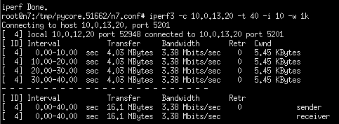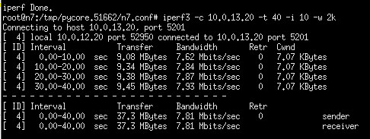
Figure ‎1-1 1Kbyte windows size Figure ‎1-1 2Kbyte windows size
Throughput: 0.4025 Mbyte/sec Throughput: 0.9325 Mbyte/sec
Average number of retransmissions: 0 Average number of retransmissions: 0
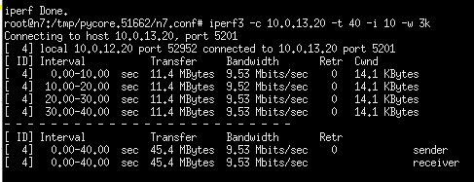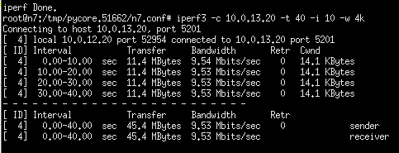
Figure ‎1-1 3Kbyte windows size Figure ‎1-1 4Kbyte windows size
Throughput: 1.135 Mbyte/sec Throughput: 1.135 Mbyte/sec
Average number of retransmissions: 0 Average number of retransmissions: 0
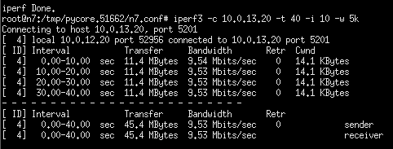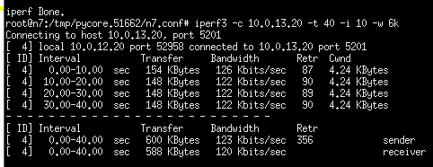
Figure ‎1-1 5Kbyte windows size Figure ‎1-1 6Kbyte windows size
Throughput: 1.135 Mbyte/sec Throughput: 0.015 Mbyte/sec
Average number of retransmissions: 0 Average number of retransmissions: 356
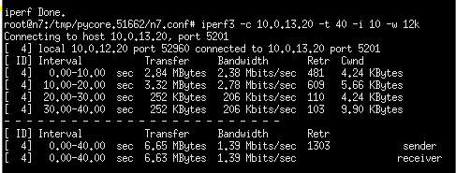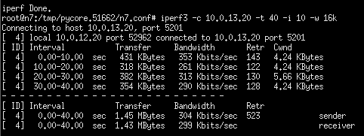
Figure ‎1-1 12Kbyte windows size Figure ‎1-1 16Kbyte windows size
Throughput: 0.16625 Mbyte/sec Throughput: 0.03625 Mbyte/sec
Average number of retransmissions: 1303 Average number of retransmissions: 523
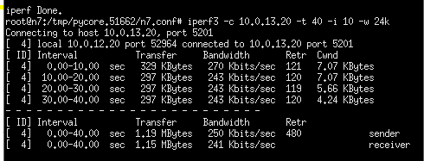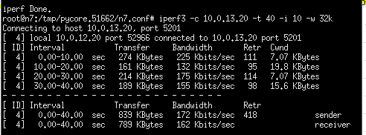
Figure ‎1-1 24Kbyte windows size Figure ‎1-1 32Kbyte windows size
Throughput: 0.02975 Mbyte/sec Throughput: 0.020975 Mbyte/sec
Average number of retransmissions: 480 Average number of retransmissions: 418
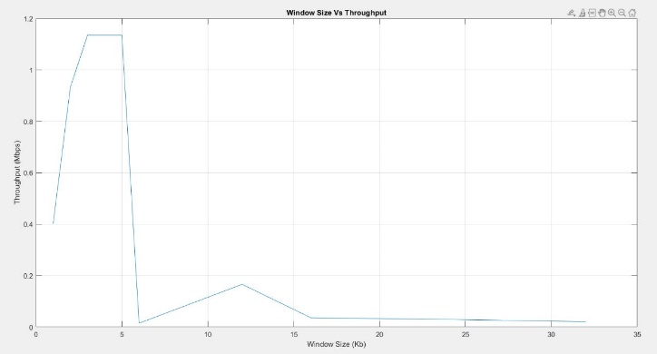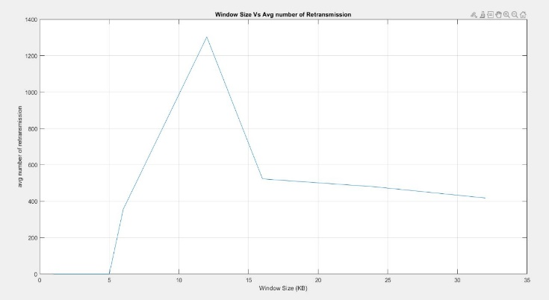
Figure ‎1-1 : throughput vs window size Figure ‎1-1 : Avg number vs window size

Comment on your findings:
𝑇ℎ𝑟𝑜𝑢𝑔ℎ𝑝𝑢𝑡 = 𝐷𝑎𝑡𝑎 𝑇𝑟𝑎𝑛𝑠𝑓𝑒𝑟𝑒𝑑/𝐼𝑛𝑡𝑒𝑟𝑣𝑎𝑙 𝑇𝑖𝑚𝑒
we notice from figure of throughput vs window size that graph take zigzag behavior when we increase the window size from 1k to 5k and also the number of retransmissions is zero because the receiver buffer is not full yet so when we increase the window size, throughput also increase until receiver buffer is full and this happen when window size is 6k so we notice that throughput drop suddenly from graph and number of retransmissions increase because large number of packets lost and when this happen the transmitter realizes this problem and realizes to dedicate more space in the buffer so when window size is 12k the throughput increase again and number of retransmissions increase but when we increase window size more than 12k the problem of receiver buffer will happen again and the buffer is full because more packets will send to buffer and will be lost so the throughput will decrease again.

Click on any of the TCP a data segment whose source is node n7, dissect the segment by following different protocol layer headers from TCP->IP->Ethernet identifying how many header bytes are added by each layer, identify the TCP options used.
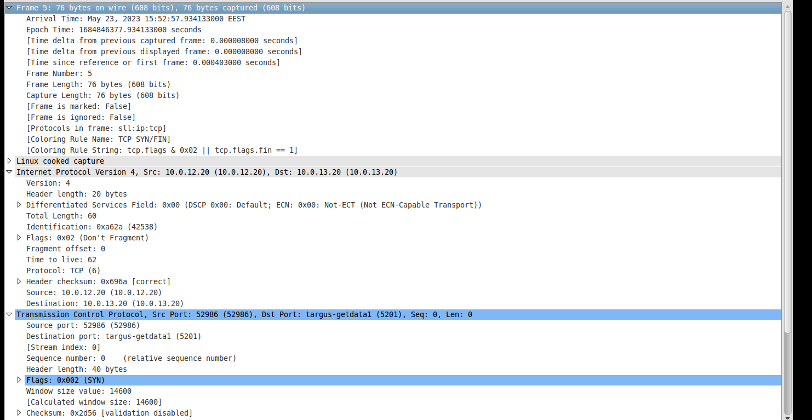
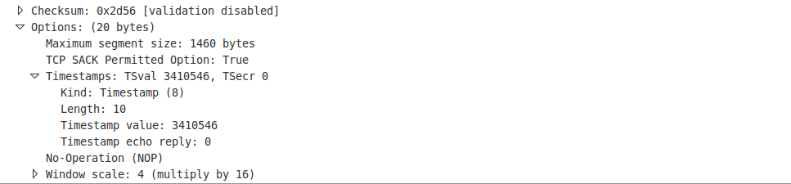
Figure ‎1-2 : TCP packet
Comment on your findings here:
- Frame : 76 bytes
- IP Header : 20 bytes
- TCP Header : 40 bytes
- TCP Options Timestamp : 20 bytes
- Ethernet Header : 16 bytes

Repeat for an ACK packet sent from node n11.
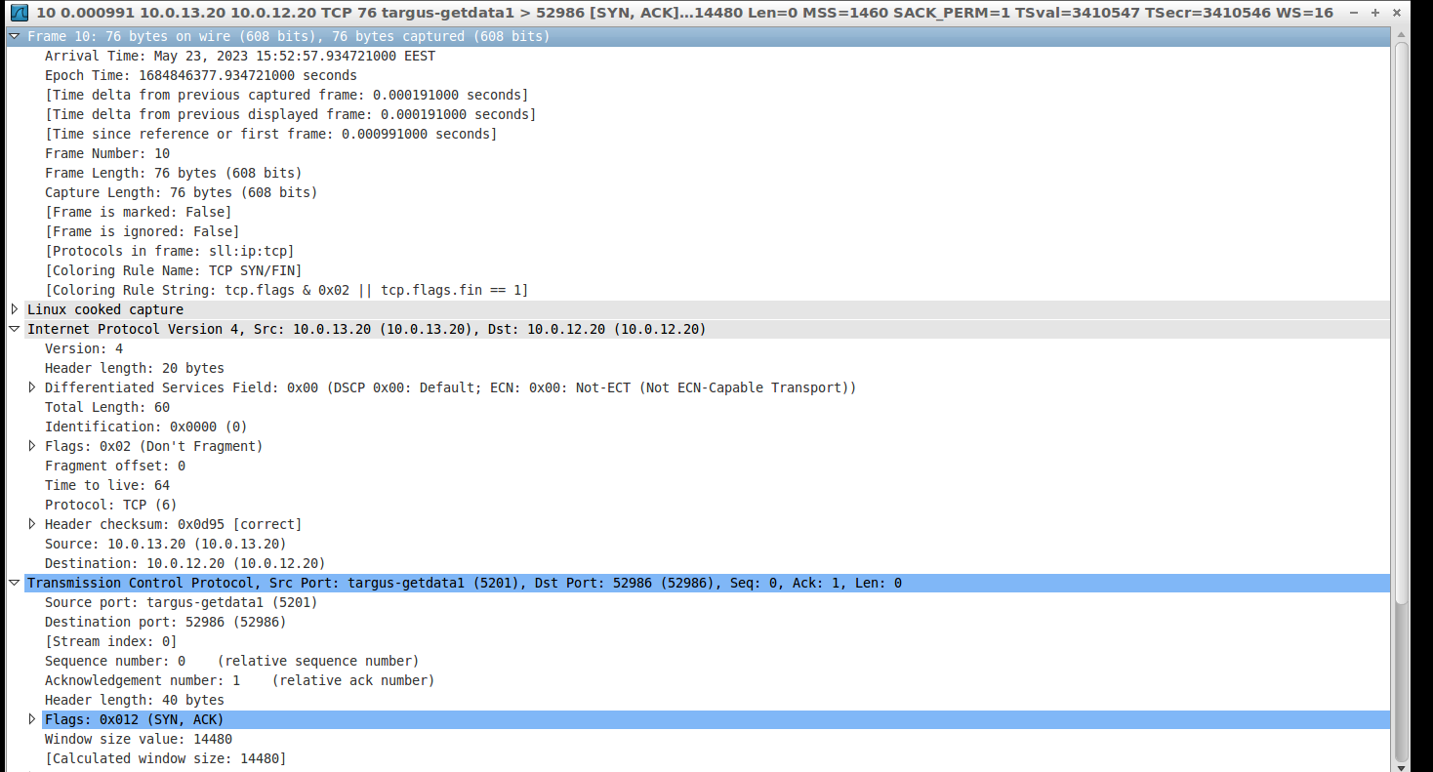
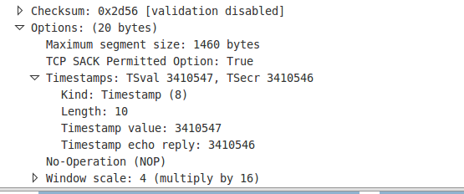
Figure ‎1-3 ACK packet
Comment on Your findings:
- Frame : 76 bytes
- IP Header : 20 bytes
- TCP Header : 40 bytes
- TCP Options Timestamp : 20 bytes
- Ethernet Header : 16 bytes

TCP short VS long paths
- Run an iperf3 server on node n8.
- Start an iperf3 client on node n7 connecting to server on node n8 for a duration of 40 seconds and reporting interval of 10 with window size 4K.

Compare the result of throughput with the case when connection was made to node n11. Why throughput drops when connecting to n8 although capacities on the two paths are the same.
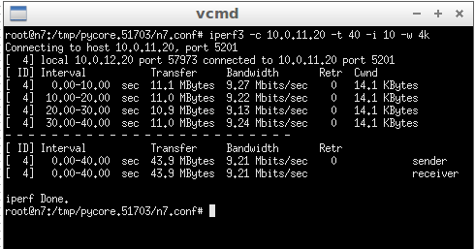

Figure ‎1-4 : from n7 to n8 Figure ‎1-4 : from n7 to n11
Comment in your findings here:
- Throughput from n7 as clint to n8 as server: 1.0975 Mbyte /sec
- Throughput from n7 as clint to n11 as server: 1.135 Mbyte /sec
we notice that when n8 become serve instead of n11 the throughput decreases because the path from n11 to n7 is larger than path from n8 to n7 and so delay will increase

Higher link Capacity with Drops VS Reliable Lower Capacity
This questions for this part are based on the path between n7 and n11.
For each case of the following, run iperf3 client from n7 to n11 with window size 4K.
- Select link between n4 and n5, configure it to have capacity of 10 Mbps with zero loss in both directions.
- Select link between n4 and n5, configure it to have capacity of 3 Mbps with zero loss in both directions.
- Select link between n4 and n5, configure it to have capacity of 10 Mbps with 5% loss in both directions.
- Select link between n4 and n5, configure it to have capacity of 100 Mbps with 10% loss in both directions.
- Select link between n4 and n5, configure it to have capacity of 10 Mbps with 1% loss in direction from n4 to n5 and 0% loss in the other direction.
- Select link between n4 and n5, configure it to have capacity of 10 Mbps with 0% loss in direction from n4 to n5 and 1% loss in the other direction.
Please fill the following table with the AVG throughput of each case:
Case | Throughput | figures
A | 1.135 Mbyte/sec | 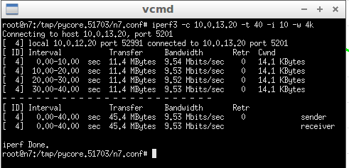
B | 0.34 Mbyte/sec | 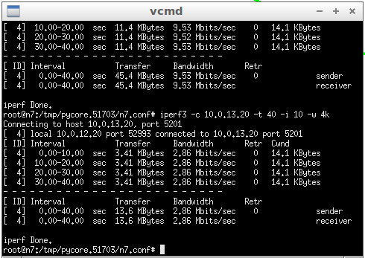
C | 0.08875 Mbyte/sec | 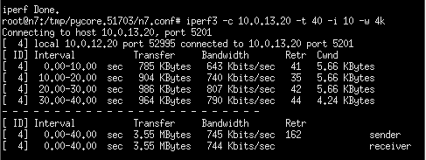
D | 0.015375 Mbyte/sec | 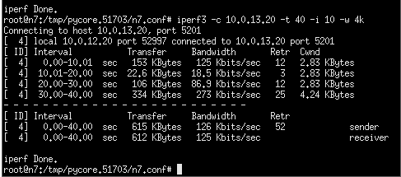
E | 1.1125 Mbyte/sec | 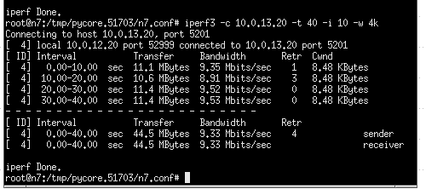
F | 0.4675 Mbyte/sec | 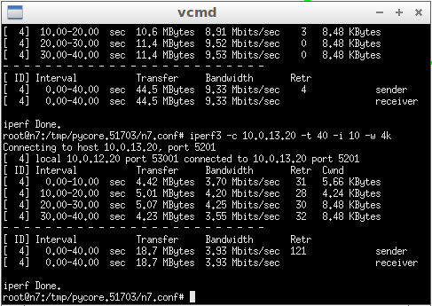

Compare throughputs in cases a, b, c. Why b is better than c?
Comment in your findings here:
we notice that throughput of case A is greater than throughput of case B and throughput of case B is greater than throughput of case C so case B is better than case C although capacity of the link in case of c is grater than case of b but losses in case c grater than case b so we need to retransmission packets in case c but in case b we do not need it because the losses is 0% and the throughput of case A is greater than case B because capacity of link in case of A is greater than case of b

Compare throughputs in cases b, c and d. Which is better? Why?
Comment in your findings here:
Case b better than case c and d because the loss in case b equal zero in both direction so client or server will not retransmit any packet although capacity in case b is lower than capacity in case c and d but in case c and d will retransmit packets because loss not equal zero

Compare throughputs in cases e and f? Which is better? Why?
Comment in your findings here:
case B better than case f because packets with large size is often send from n5 to n4 (from client to server) but the packets was sent from n4 to n5 is often with small size because it is just ACK or not ACK so losses will affect the link between n5 to n4 more than n4 to n5 because we need to retransmission large packet size

OSPF Lab
Each of the following sections describes an experiment based on the network topology provided by the Project_OSPF_TCP.imn file.
The Introductory Lab explained and introduced most of the needed tools like iperf3, vtysh, wireshark, etc. If you have not gone through it, do not start working on the assignment below.
It is better to start the network emulation once and run Wireshark captures. You can reset Wireshark captures from experiment to another.

OSPF Link Cost Change
- Stop any running iperf3 clients.
- Set all links to have zero loss in the two directions with 100 Mbps speed.
- Run iperf3 between n7 and n11 for a duration of 500 seconds or longer. Identify the path between n7 and n11.
- Open vtysh on node n5 by opening a bash terminal and typing vtysh. Now we can configure router and link costs.
- Type the following in vtysh: show ip ospf interface eth1 (To know the ethernet number of each interface you can choose toolbar->view->show->interface names) This displays information about interface eth1. Note its ospf cost.
- Type the following configure terminal
- interface eth1 (the interface for the link between n5 and n4)
- ospf cost 40 (set cost to 40)

Check what happens to the path between n7 and n11 (as seen after steps 3 and 6)? Explain what happens. To help visualize the path choose toolbar->widgets-> Throughput.
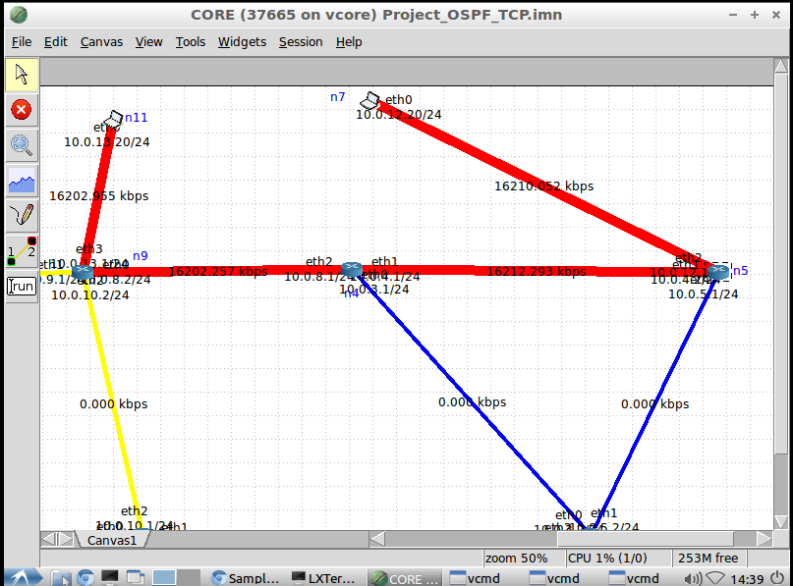
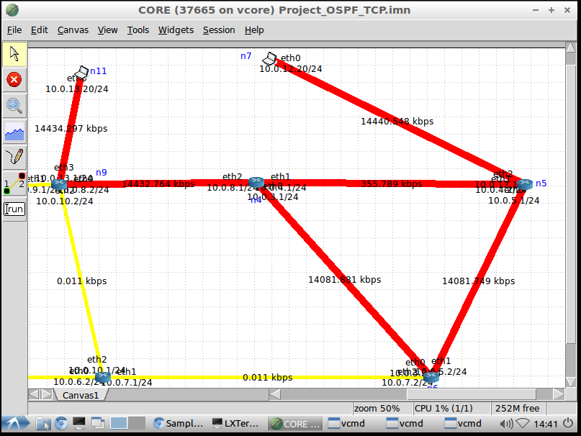
Figure ‎2-1 before Figure ‎2-1 after increases the cost to 40
Comment on your findings:
When there is congestion due to high link cost, the router selects an alternate path with a lower cost using Dijkstra's Algorithm.

Set the cost of eth1 at node n5 back to 10. Establish two iperf3 connections: one from n7 to n11 and the second from n11 to n7 both for duration of 500 seconds. Now go to node n4 and set interface cost for interface connecting n4 with n5 to 40. What happens in the paths of the two connections? Explain what happens. What do you conclude?
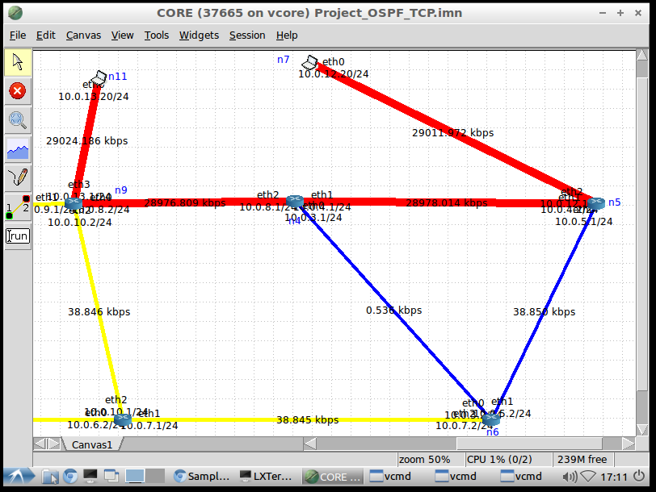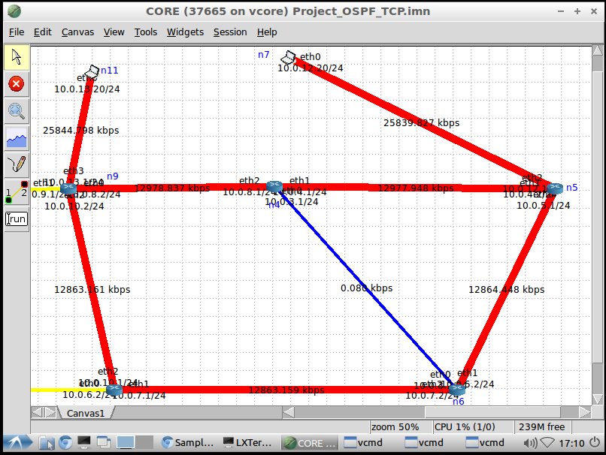
Figure ‎2-2 before Figure ‎2-2 after increase the cost
Comment on your findings:
The path becomes much longer for the same reason mentioned above. The increasing cost of a link prompts the router to select another path, even if it is longer, to alleviate congestion.

OSPF Database Updates
- Start wireshark and have its filter to capture only OSPF related packets.
- Go to another router say router n2, open vtysh and issue the commands:
  - config terminal
  - show ip ospf database (check this link to understand more)
  - show ip ospf route
- On router n4, set link cost of eth1 to 20. Capture the link state packets advertised in Wireshark.
- Go to router n4, go out of vtysh, or open new bash terminal and issue the following commands to disconnect router n4 from the network:
- ifconfig eth0 down
- ifconfig eth1 down
- ifconfig eth2 down

Capture and explain the outputs due to execution of step 2. Why some destinations have more than route in the routing tables?

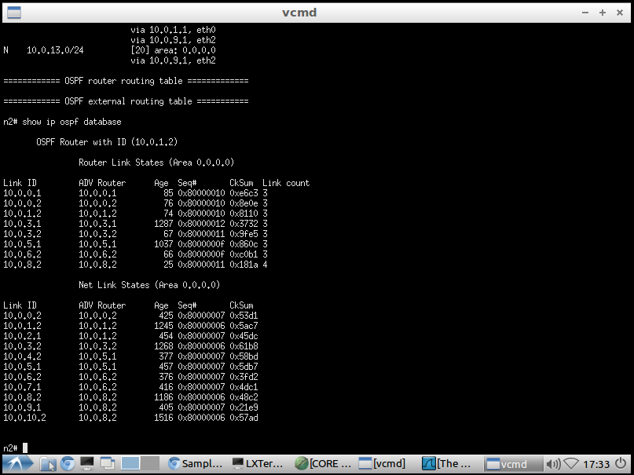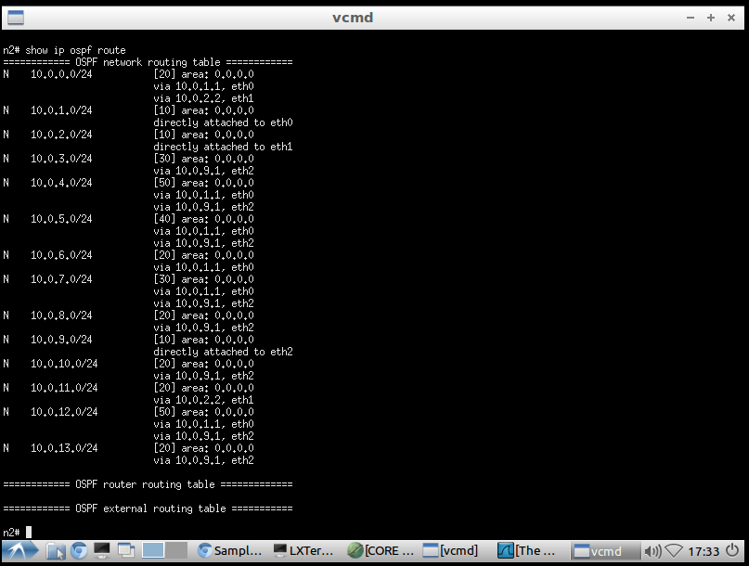
Figure ‎2-3 database Figure ‎2-3 route
Comment on your findings:
Because there are more than path has the same cost. So, switch can select any one of them. Also, if one of the paths is down, there should be another one.

After executing step 3, determine how long it took the network to exchange link state packets and adjust routing tables. (Hint: you can calculate the required time by observing the time of first OSPF update message and the last ACK from Wireshark).
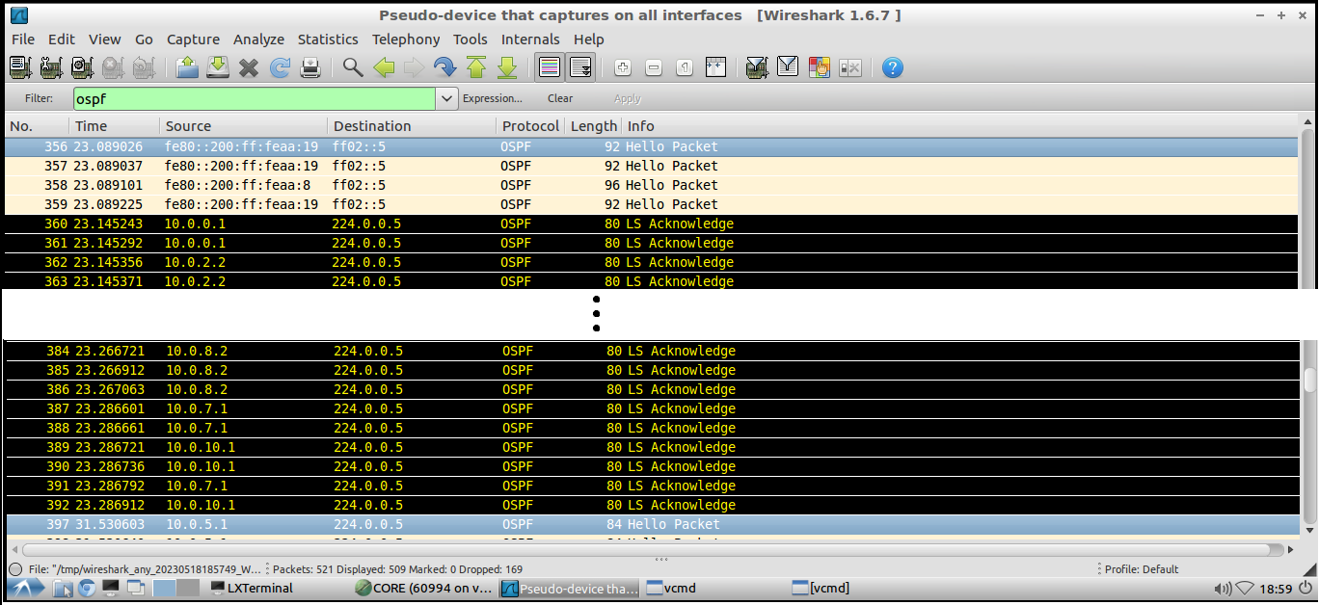
Figure ‎2-4 Put your screenshots here
Comment on your findings:
Time taken = 23.286912 – 23.145243 = 0. 141669 sec

After execution of step 4, identify the new routing table and router database at router n2. Explain the updates in the new routing table and the new database.

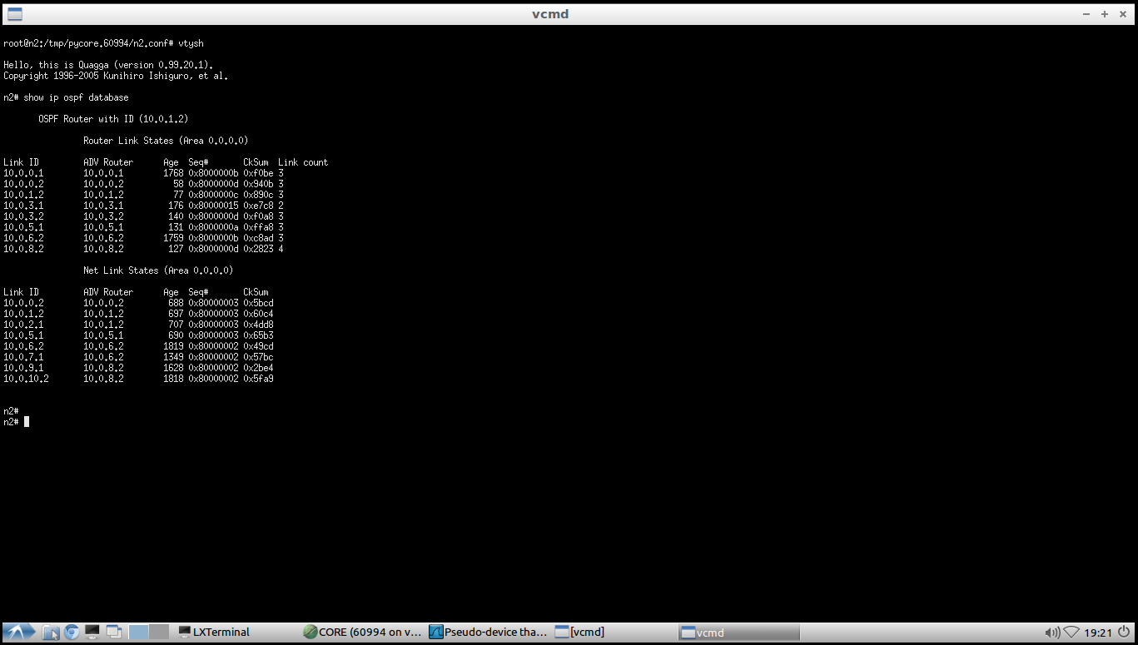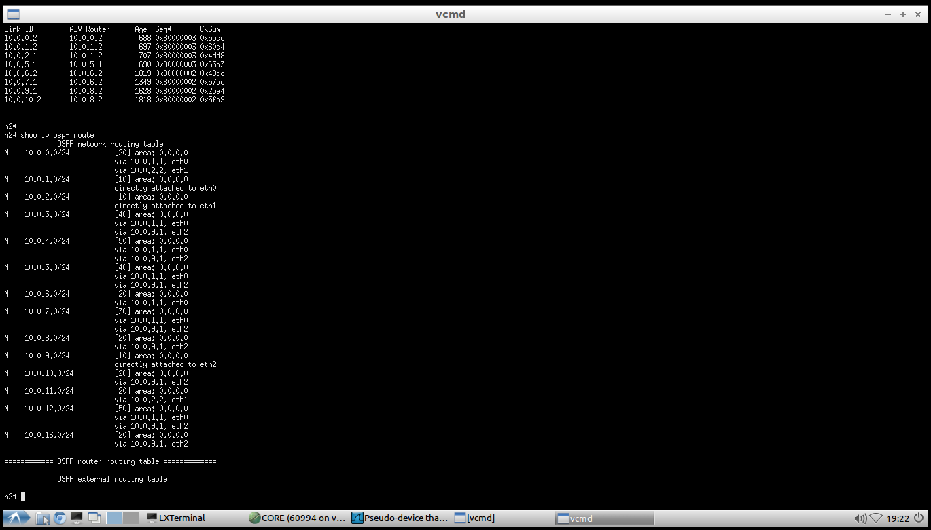
Figure ‎2-5 database Figure ‎2-5 route
Comment on your findings:
When we disconnect the N4 node, there should be another node to take its place, which is N2. N2 has a higher cost than N4, so the update will be shown in the database.

OSPF Link State Advertisement Periodicity
This part is on your own. No instructions are given. Bring router n4 ethernet interfaces back up.
Stop any previous iperf3 connections. Let Wireshark capture focus on Ospfv2 only (IPv4).
Apply the filter (ospf.msg.lsupdate || ospf.msg.lsack) && ip.addr == 224.0.0.5

Bring router n4 down and then up again and determine how long it took the network to recognize the router is down/up.
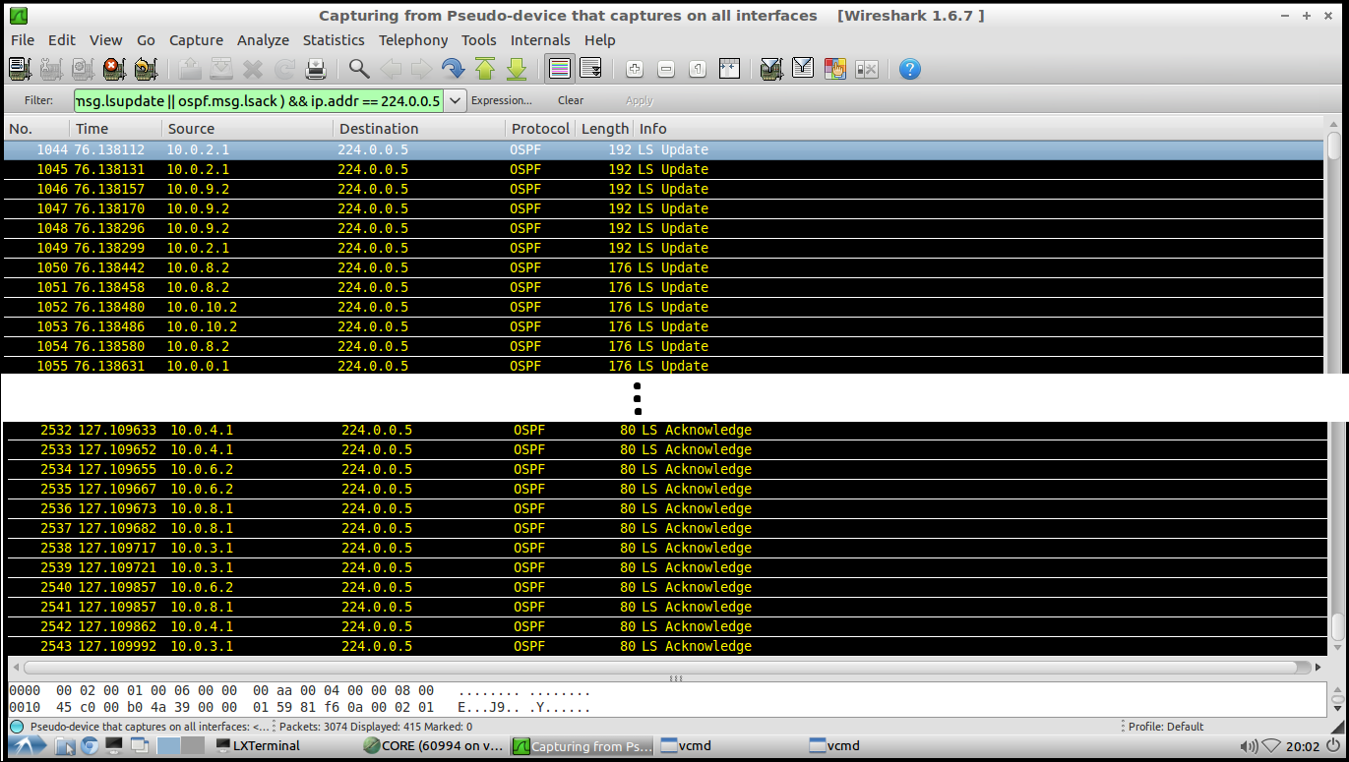
Figure ‎2-6 down time
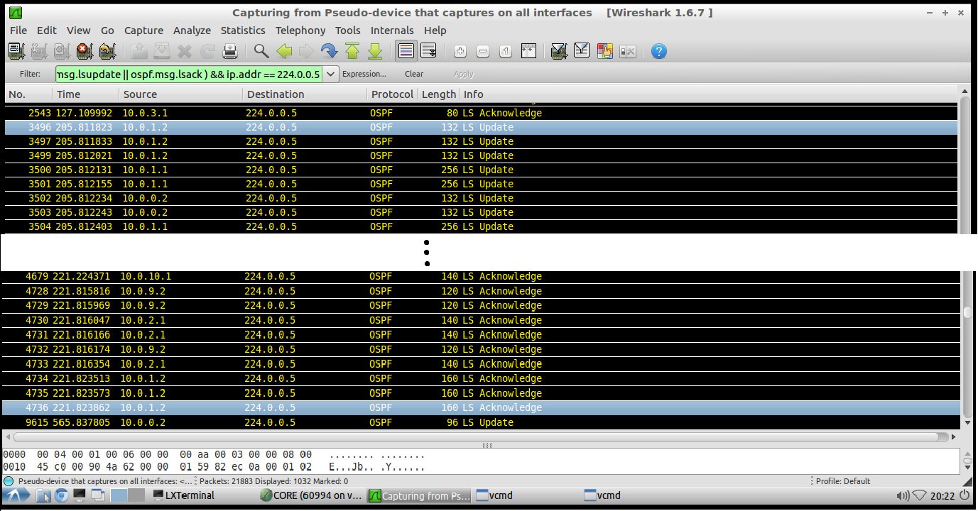
Figure ‎2-6 Up time

Comment on your findings:
Time taken to recognize it’s DOWN = 127.109992 – 76.138112 = 50.97188 sec
Time taken to recognize it’s UP = 221.823862 – 205.811823 = 16.012039 sec

Now, the following is a bonus question (extra marks). Explain the noticed behavior of the link state update packet storms (flooding) where it generally takes longer times for the LSP exchange to die out (i.e. LSP exchange stops) when a router is down as compared with the case when the router is up again.

Comment :
When a router goes down, it may take some time for the other routers in the network to recognize that it is no longer available, When a router goes down, it stops sending hello packets or responding to them. The other routers in the network will continue to send hello packets to the failed router, but will not receive any response. After a certain amount of time (known as the "dead interval"), the other routers will declare the failed router as down and will update their routing tables accordingly. As a result, the other routers may continue to treat the router as down for a certain amount of time (known as the "hold time"), even though it is actually up again.

